Creation P4

[*Link for the site*](https://certifiedjimenez.github.io/Project-Riverside-Retail-Park/RiverSideRetail/)

[*Video of the website*](https://youtu.be/ixDJ8kd2hQI)

In terms of the creation of the website, my website provides a consistent layout throughout the website and it has a skeleton template being the main overhead menu bar that follows throughout the website, the only thing that changes is the lower line hovering to indicate which tab you are on indicating the interactive element of the website which is a very small but effective change as it shows to the user the website is intact responsive and helps them to understand which tab they are on impacting the customer experience on the website to be simple and clean making them navigate through the website at ease. The website in its general form has more than 5 Pages which these include the following: Shop online (main page), Norwich Kitchen, Online raffle, Restaurant & Cafe, About us. The other ones that are not included are Allstores and the Error404 page.



This provides the only menu the user will need to navigate around keeping it simple around the website besides the search bar that can redirect them into any store instantly but unfortunately, I haven't had enough time to complete it all it just does is redirect to the home page if it hasn't found anything relevant. The code on the creation I used Bootstrap and CSS to give the appearance and functionality of it. I’ve used the latest version of HTML.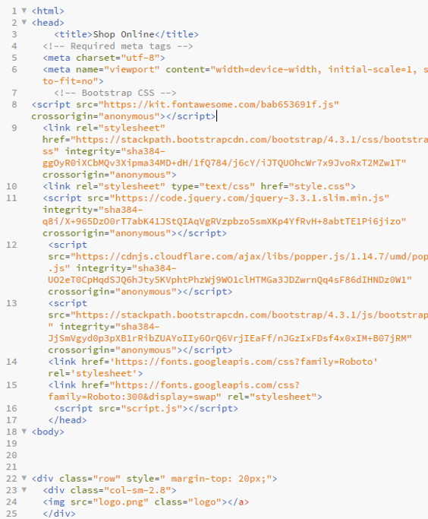

With this I’ve imported the CSS code into the HTML file in line 13 -14. The next is the CSS file being applied to the HTML file to keep clean and speed the optimisation which is in line 10 I’ve imported some Icons as seen in line 8 used for the Shop online page.

[*Evidence of the review*](https://youtu.be/i3NDRUZEFVM)

I've even gotten an example of a default template for each website in the even I required to make a new page I just copy and paste the initial template of the HTML and then I build on top of that to keep the consistency flowing and speed up the development. For each store page I’ve also used a template meaning they all look the same providing the consistency but it also speeds development as I copy and paste and change each individual properties of the website to fit the information needs of what the client wants to see regarding which store they are on keeping a consistent informative feedback on every webpage with little effort making it easier to make them and provide good information at the same time meeting the needs of the clients each web page. Also every part of the website has a footer informing the user that “This site is the Norwich Retail Park, for more information or legal inquiries please email Enquires@NRP.co.uk” This tells them the user where to contact them at any part of the page for the legal requirements meeting the legal standards on every website that’s regulated and this builds trust between the clients and knows where they can contact the riverside retail parks email.

For every template page I have the top menu and for every default page copy and paste the 404 error page and then edit it fit the needs of what the page on what it needs to be, for example a for a checkout page I would copy and paste the HTML file and I’ll change the 404 error message or remove it completely as a template to build on during development of the page. As for the store template I ensured it will have an image of the front store and then a long text description that gives brief information. If the user, then inquiries to find out more they can see the opening and closing times and If they are not satisfied, they can click the original site link that redirects them into the original site.

[*Evidence of the review*](https://youtu.be/-W_ugSY_XQ8)

As for JavaScript , my website is full of JavaScript to make it more interactive for each user. They can be found during the login session when clicking sign up or login or checkout for the raffle when it displays a message or when clicking the card to redirect the user to the web page of the store on the home page or the store's page

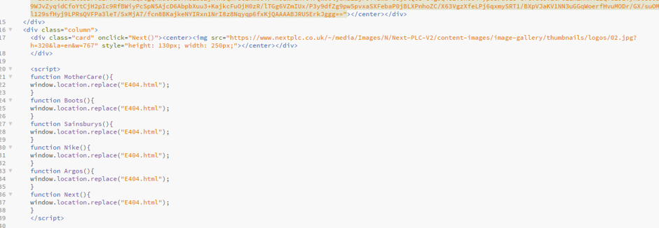This screenshot is the home page where the cards are displayed and each of them has an event driven function that redirect them into the Error 404 page saying the website is offline or doesn’t exist as a test and it is confirmed it works.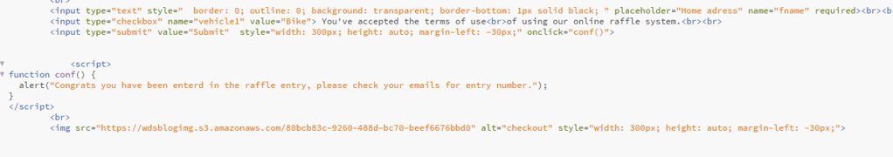

Here we have the checking out process and once the button is triggered and the events are true the browser displays a message confirming that the user has submitted successfully and they have now entered the raffle this creates the element of interactivity with the user and the web page establishing a live communication that makes it appear less still unlike other sites this was all possible through the programming of Javascript, I’ve made a function so on the event the button gets pressed it activates the function in between the *<script>* tags called Conf. An alert message will pop up alerting the user that the website works.

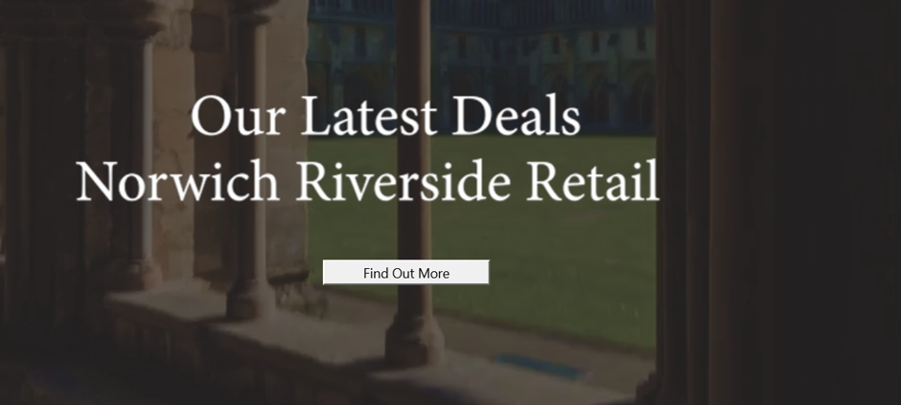

I’ve also added a video at the bottom showing of the deals at the Norwich Riverside Retail enlisting that the website is alive by the over exaggerating video in the background, once clicked it’ll redirect you to a deal page which is the raffle checkout page.

Evidence

Like mentioned previously, you can see the screenshot or click on the YouTube links to see the interactivity and videos of the website. Also, regarding the CSS I’ve imported fonts that are clean and can be read by anyone that gives it a modern look called ROBOTO. Here is evidence of me importing the font to the CSS and me using CSS to get the upper menu bar working and looking good, meeting the users requirements of keeping the website simple and the typography clean to ensure all users can read it meeting their requirement of understanding the web page. I’ve uploaded the files regarding the website to the FileZilla online cloud library.

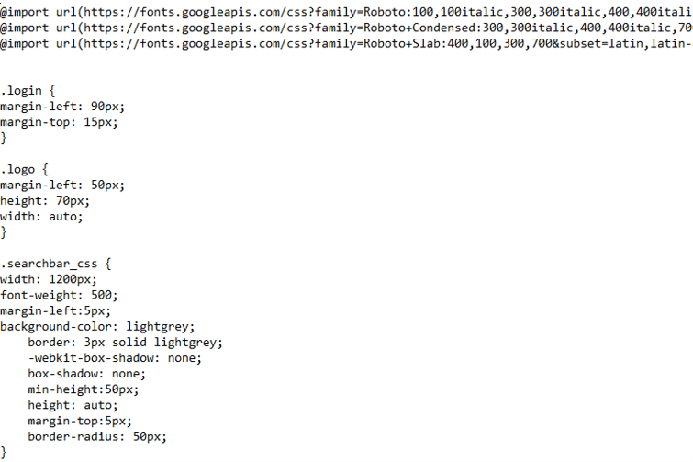

This is a seperate text CSS style from the HTML but every HTML website access it in order to load up the default standard for each website (The main top menu) . The “@import” CSS code imports the code through the URL via the Google fonts link this improves the optimisation loading times meaning that the website doesn’t have to save the fonts in the server reducing loading times but instead it optimises.

The “.Logo” CSS code align the code at the top left that keeps the Logo in the same place and it aligns correctly so no matter if the window size is increased the logo remains a fixed distance from the top and left not keeping it too close to the left side nor the top.

The “.Login” will remain distance from the search bar keeping it spaced out and from the top. The “.searchbar_css” is kept at a fixed width and customising the colour of the search bar to blend the colour scheme of the website giving a nice blended look.

FileZilla

I’ve logged into the FileZilla servers and uploaded the folder files into the FileZilla so my website can be accessed via the internet.

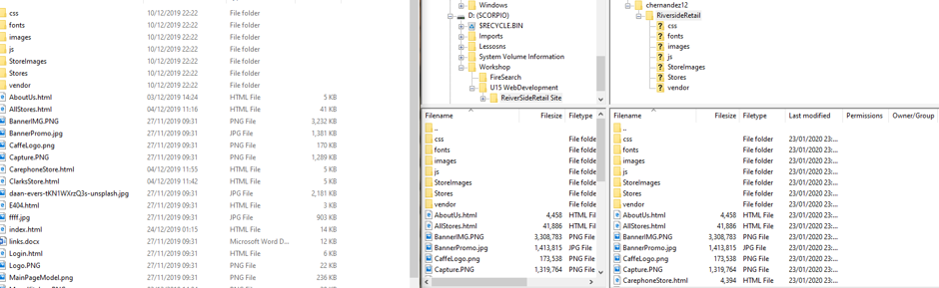

Testing P5

Regarding taking input for my website in the form of a survey to ensure all the requirements of the target audience matches and meets their intended use. So, I've section three main queries on what their person fulfilling the survey must answer.

**Testing Table**

|  |  |  |  |  |  |
| --- | --- | --- | --- | --- | --- |
| Test | Location (Page) | Expected Result | Justification | Actual Result | Evidence |
| Allows the client to submit an order on the raffle page and ensure it works correctly. | Raffle Page | Once clicked on submit if all fields entered correctly it pops up am message | Fits the requirements of the website having a promotion to an online raffle and allows the user to purchase a raffle ticket online. | Pops up a message on the user informing they’re in | <https://youtu.be/oKc33bFG0tA> |
| When you click on open on Google maps it redirects you to Google maps | About Us | Click on open maps and it redirect you to Google maps | This fits the requirements of the target consumer as they will show the information regarding the location in the event they want to visit it. | It redirects you to Google maps with the location automatically typed in | <https://youtu.be/SEvjrrfsFqU> |
| When you click on the card it needs to be able to have an element of interaction that redirects you to their store page. | Shop online | When clicked to a card it redirects you to a 404-error page | This is useful as this displays all the facilities the Norwich Riverside Retail Park offers meeting the requirements of informing the audience what the Riverside Retail Park offers. | It redirects you to an error 404 page and you can click return to go back. | <https://youtu.be/SEvjrrfsFqU> |
| Make sure a login page is available for recurring customers having an ability to login their accounts. | Login | Click on login and informs you can’t log in due to a presents check. If you click return you can go back to your previous window. | Used for marketing the Retail Riverside Park and creating personalised user accounts can be a great way for email marketing can be introduced and inform the users on any new events on the Norwich Riverside Retail Park . In this case the (Online Raffle.). This can also be a direct way to contact customers via the accounts. | It goes into the login page correctly and you’ll need to fill out the username and password and then it refreshes when it loads and it returns back to the window | <https://youtu.be/SEvjrrfsFqU> |
| Works in different browsers (Edge, Firefox) | all pages | Work as expected in every possible way as I was running in Chrome or Microsoft Edge. | This is essential for the optimisation of the website as it needs to be able to be accessed by a wide range of users using different devices and this includes using different browsers. | Works as expected in every aspect and doesn’t provide any technical issues if anything it works better. | <https://youtu.be/vwaHybkQltY> |
| Most users use a mobile device to browse the internet so I’ll need to ensure the website can be used my mobile users. | Mobile version site | Work normal and experience some issues but overall fine | This is important because there will be a guarantee that the users from mobile platforms will access the website and as previously mentioned you’ll need to be able to have a lot of users from across any platform to visit the site inorder to have a wide range of consumers access the site | Some pages are better than others at representing each other but the mobile version doesn’t work as well but still manageable |  |
| Navigation links need to be able to work at all times and redirect users to the right page. | (each page separately) | When clicked on each individual link it redirects you to the right page. | The reason is because redirecting the user is a beneficial way of transit around the website making it easier for the user to find relevant information quickly fitting its purpose of making it easier for the users to be able to navigate. | The links redirect you to the right page and some pages like the stores I didn’t have enough time to develop their store pages individually so I made it redirect to the Error 404 page information their users the web page is under development. | https://youtu.be/ixDJ8kd2hQI |
| Fit for purpose | All pages. | Have information on the riverside retail | This is essential as the websites target audience is the most crucial thing as targeting the right audience means it can help a business thrive and makes use of a website. Having a website without a predefined target audience is a waste because it’s not bringing in any targeted customers meaning it doesn’t meet its purpose. | It has information regarding the RiverSide Retail. | <https://youtu.be/vwaHybkQltY> |
| fit for target audience | All pages | Conservative colour scheme and short paragraphs that's easy to read and provides a range of shops to suit the clients needs. | This is essential as the websites target audience is the most crucial thing as targeting the right audience means it can help a business thrive and makes use of a website. Having a website without a predefined target audience is a waste because it’s not bringing in any targeted customers meaning it doesn’t meet its purpose. | It has conservative colour scheme and short paragraphs that's easy to read and provides a range of shops to suit the clients needs. | <https://youtu.be/vwaHybkQltY> |
| All elements display as expected  Good colour contrast  Consistent layout | All pages. | The website is supposed to look good and appropriate and also have a very consistent layout. | This is essential because the look a website can gain the users trust and giving a good colour contrast gives the user a mood and a feel for what the website is representing. A consistent layout provides familiarity between the user and the website meaning that hey can use your website more fluently as they know what layout of your web pages contain. Elements are supposed to display appropriately and can be read and work as expected. | Harvesting data from my survey all participants said the websites content are understandable and the aesthetics of it *(including colour and consistency)* are above average, meaning it is very good and it meets the requirement of having a good color contrast and a consistent layout and displaying all elements. | <https://youtu.be/vwaHybkQltY> |
| SPaG checks and contents are understandable | All pages. | Spelling, punctuation and grammar is supposed to be clear and can be read and understood by all users. | This is important as users need to be able to understand what their reading and Spag is an element of that. Having incorrect grammar or spelling would make a website look unprofessional or perhaps a scam losing customers. | Regarding my survey participants said the website is understandable when I asked them if the context of the website can be understood including SPAG also I’ve written the content of it in grammarly to ensure there's no SPAG errors. | <https://youtu.be/vwaHybkQltY> |

Test 1: Works very well and makes me ensure I fill all the requirements and the message pop up displays whenever I type valid info and displays a message to confirm I’ve entered the raffle, meeting my requirement as the user to know if my purchase was successful.

Test 2: Redirects you perfectly to Google Maps with the riverside retail park link already opened, meaning as for the consumer it easier for me to navigate and it can redirect me to the mobile version if I was using a mobile device that has google maps installed.

Test 3: Takes me to the error 404 page whenever I click anywhere around the card not just the logo, makes navigation more efficient and successful and shows the website is active.

Test 4: Takes me to the login and I must fill in the regarding information as a present check else an error message will pop up meaning that I have failed the presence check. When filled and I lick login it does what I expect which is to refresh because it isn’t connected to a database meaning it gathers the input correctly as expected and once I click on return it redirects me back to the previous page I was in.

Test 5: compatible on Firefox and works better than Microsoft Edge and they both provide the same result in each test, so it's safe users of all browsers can use this website.

Test 6: converted my browser into a mobile view and the website sometimes looks good and sometimes bad but it can still be used to navigate but some options are navigated elsewhere making it a little discomforting when using it, but it still works more or less.

Feedback & Review (P5, P6,D2)

The target audience age is for 16 and over, there will be places open to that will appeal to older people in their 40s such as Argos and other places that will appeal to people in their 20s like Nike. Stores such as Mothercare can appeal to families specifically mothers and Boots can target both men and women around their 20s - 40s that are interested in their health and beauty care. In terms of demographic this again depends on the stores and what client it attracts but most will be in the middle and lower demographic.

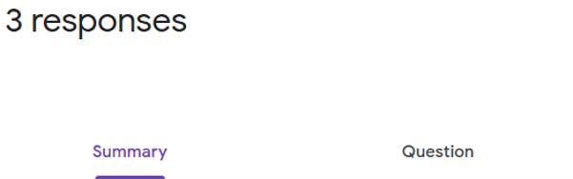

Three main participants were filling out the survey when it was conducted. The first section would be asking the user to determine the appearance of the site in terms of its layout and consistency this would be because I'll need to appeal to both a 16 and 40-year-olds in my target age of the website. Determining that it not only look pleasing that it makes consumers want to return to the website again but does the job of informing people and making it simple to use. This was a major concern for the website, so I decided my most reliable option would be to keep a clean consistent layout through that can be utilised by users of all age and by using some icons it can help users who don't understand the English language properly to navigate around the website successfully communicating with the clients and meeting their needs for the websites intended use. I've also decreased the amount of text used in a paragraph and simplified it all, example the website has no more than 3 lines in each paragraph maximum meaning that it not only makes it quicker to read and memorise it meets the instant gratification of modern-day consumers. I've used a grey colour layout scheme to represent the urban city environment because most consumers that go there are living in Norwich central and by providing the urban stone consistency throughout the website. This makes the younger urban city consumers feel more at ease with the colour of the site and the logo and give the idea the location will most likely be in the city. The older audience would positively react to the grey as having too many bright colours might push them away but grey can also represent a still and calm according to colour psychology making them feel at ease when using the website rather than having bright and spammy colours attracting a younger audience. Lastly, the grey also represents simplism and is a general clean colour used that gives off a little eye attention but doesn't make it too noticeable again meeting the needs of keeping the website consistent and easy to read and understand.

<https://forms.gle/cWoPceTVg2dqM67c7>

The first question there was a 5-option survey and the options being called "Amazing", "Good", "Alright", "Bad", "Terrible" that the survey participants had to answer. 33.3% said "good" as a response as its satisfactory and an overwhelming 66.7% said amazing meaning it passed the participants expectations. what I gathered from this 100% of participants were pleased with the looks and didn't really complain about the look of it achieving the making of the website look pleasing indicating that I've already met a requirement.

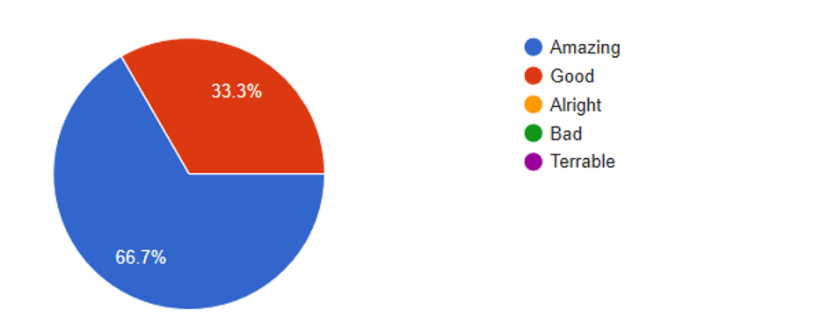

I've next asked the participants of the survey if the website suits its purpose. By purpose, I mean three main concepts: is it informative? Can you understand it? Is it simple and easy to read? This translates if this hits the criteria of the website suiting its designed. There were 3 options you can select on the following question. "Yes" "Sort of" and "No" all the participants agreed that it did, in fact, meet its purpose but because during the survey the website was not fully completed 66.7% selected "Sort of" this means it has passed it succeeds its expected result but not fully meaning there were areas for improvements, 33.3% said "yes" meaning they were satisfied. I've then narrowed down and asked the participants to explain their reason further so I can diagnose and know where the issue sprawls.

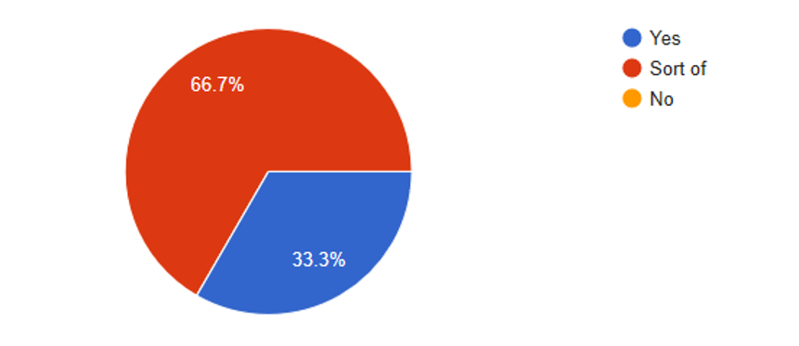

One satisfied participant said, "The website is directing to the pages and shows all the details that are required" showing that he, in fact, agrees the website meets is purpose. One mention "It mostly does but is incomplete, also the fact that it only works at 80% is not acceptable for a public website in my opinion." I've followed up with the participant later on and asked if they can elaborate further they mention that "The menu tabs are not functional" This because the website was in construction, So I've decided to add the level of interactivity in the menu tabs by adding a black line to represent which website the user is on and finished to fill in the rest of the menu tab meeting the requirement of fulfilling its purpose in terms of navigation.

[*Evidence of the review*](https://youtu.be/A-gOdagCz_s)

One of the explanations mentioned that the raffle page isn't complete meaning that it'll need to be finished off fitting the website's purpose. The participant said "Some areas of the site are still not operational, and ticket ordering was not implemented yet" this means I had to complete my raffle page.

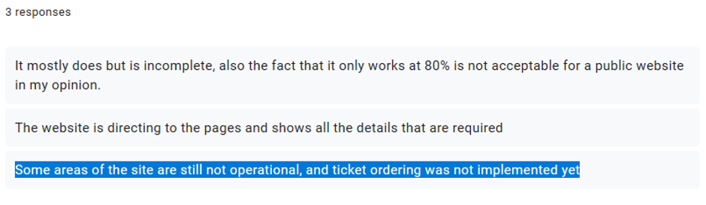

Comparing to my initial design, I've decided to leave it simple and clean looking professional as to when the customer checks out they can securely feel confident when checking out instead of using pink as a submit colour because it would look too childish and only attract the younger consumers and since we had to attract both older and younger consumers we'll need to require a balanced look that not only shows the website is official by using grey as a clean and professional colour but not to show off the website is too childish.

The original design during the interface’s development

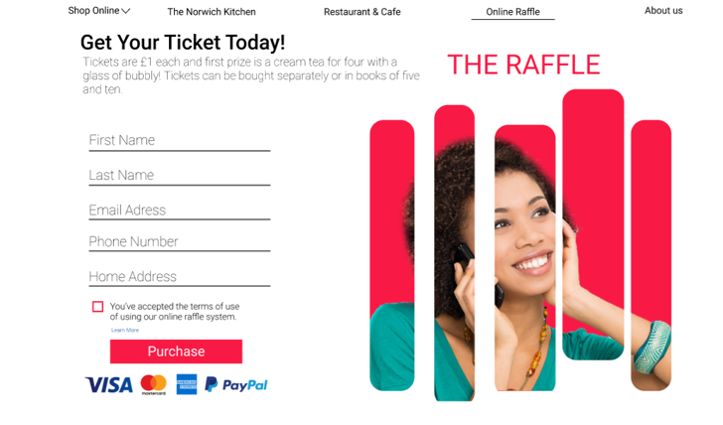

After improvements made the new look.

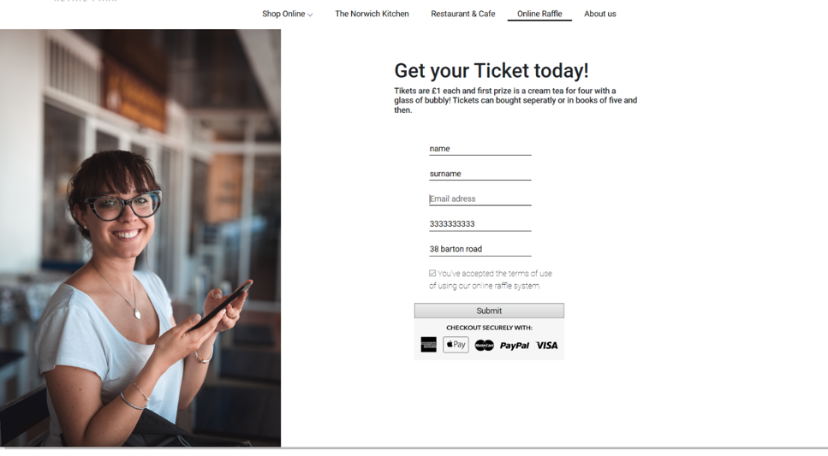

The reason I went for a less cartoonish but more professional checkout system is because using bright colours will distract the older clients and checking out will be unpleasing for them especially the image on the right that appears as if it is playing with the mind with the exaggerated colour giving an off feeling to the consumers. We didn't want that so I've decided not only will it be efficient but use more of a simple terminal to enter details where consumers of all age and gender can feel comfortable to put their sensitive information hence the new grey and clean design that looks less colourful and more secure that gives it a profession ongoing theme that let the consumers know that their information is safe with the website increasing the conversion rate of the online raffle and building trust with the customers. In both designs, one thing that I carried was always a woman smiling this would be because according to the demographics females are more likely to attend new restaurants than men determined by the demographics of females that go to Starbucks in the Riverside Retail Park. So by using a woman smiling at the camera using a phone makes it more relatable with the primary demographic and by using the phone it suggests it appeals to the younger generation as their more inclined to use mobile phones and go somewhere new meaning that the website not only meets the requirements needed by the overall age and gender, but the website knows its main primary audience and does a great job targeting them meeting their requirements. Meaning that more people will attend the raffle as they are targeting not only all ages by using the colour scheme but the left side of the page has an image of a woman it would target young females that are more likely to attend the place making it more profitable and meeting their demographic requirements.

The smiling also suggests that the women in the image are not only happy but pleased at the service of place meaning when people see the image it is worthwhile checking out the place and entering the raffle.

I've made it so the user inputs their valuable information each field is required to be entered. Meaning that no information shall be left out when "submitting" which is useful because the company can further use this and harvest the data as a marketing strategy. But most importantly it uses a presents check through each text box, meaning that it shows it hasn't been field and can't submit until something is entered before checking out meaning the design fits its purpose and does it efficiency. Once entered a text box will appear saying "thank you for entering please check your email ", as a simple to say communicate to the user telling them they have completed the entry. Instead of the Purchase, I said with the submit button because I want the consumer to feel as if they are they not buying anything but instead attempting a giveaway and by using a bald statement like buy or purchase it makes them think they are entitled to receive something at least meaning that if they lose they will be disappointed. By using this it manipulates them to purchase an entry without thinking they are guaranteed anything back. Again, a small but powerful psychological way to increase the conversion rate entry and if a consumer loses, they won't be as disappointed. By using a checkout securely with each significant payment company such as banks or PayPal it makes them feel more secure of them entering their details and makes the website appear more established.

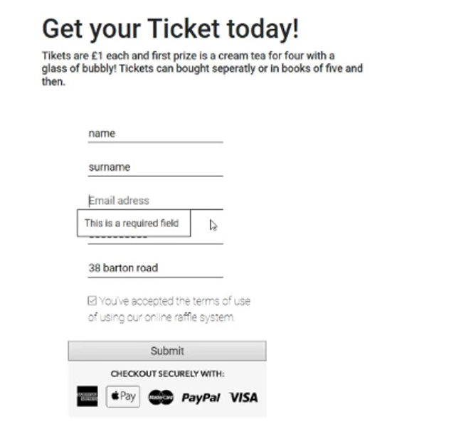

[*Evidence of the review*](https://youtu.be/oKc33bFG0tA)

Lastly, I asked does the participants understand the contents of the website. They've all said "yes" rather than "maybe" or "no" the reason I asked this is because when building a website if a consumer doesn't know what the website is about they will just leave meaning it fails to meet the requirement of every basic consumer when browsing the web which is what is the website about. 100% said yes, meaning that I've essentially fulfilled all the participants inquiries regarding what the website is about making it more successful and so it targets the right consumers. So, no improvements were made there.

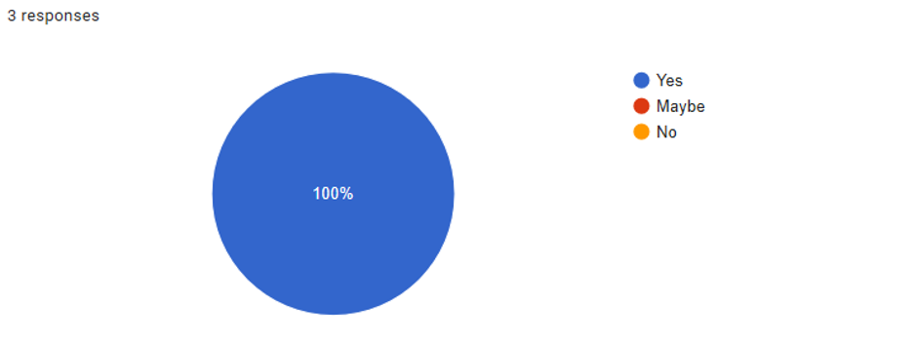

I've also wanted to take feedback on what each participant suggests so I thought of three features I should perhaps add. An email subscription or more tabs else finish the ticket order as a priority as it wasn't developed when I made the survey.

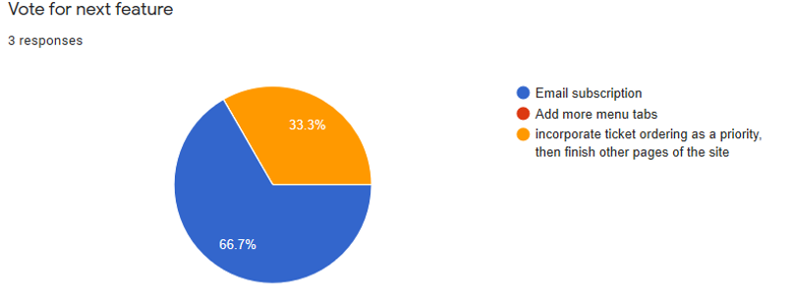

results: Most recommended an email subscription but I didn't have enough time to develop it and I don't have the services for that as well, but I could have implemented that feature in the online raffle checkout when they ask for the email and when they tick they agree with the terms of service regulation. It means when they have to click that in order to check out but one term could be that I can implement once clicked they've agreed to receive email subscriptions from the riverside retail services and use this for marketing meeting the companies requirements also. As for the ticket checkout I've completed that so I've already completed that feature and I didn't bother adding more tabs as it wasn't in demand and its unnecessary.

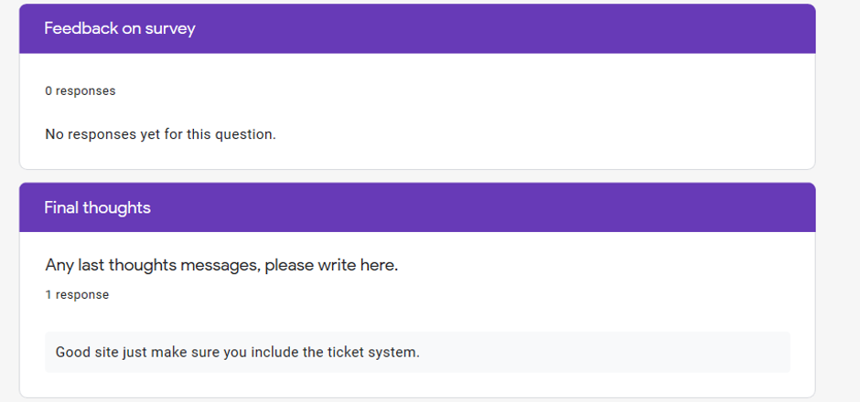

Lastly to keep the survey open I asked them to get feedback in the case my survey wasn’t clear enough but no one commented meaning that the survey was good and no additional changes to the questions where implemented nor any new questions, I’ve done this because the case could be the survey is one sided meaning that the options may be biased or something but no one mentioned it. So, its safe to say the survey was fair and I’ve allowed any final thoughts to express any opinion in what else they can suggest but only one said to include the ticket system which I’ve already did.

In conclusion, it seems as the website feedback has succeeded in the participant's expectations and further improvements were needed to be added as it met their requirements so I’ve included the option to enter an email for the raffle and finished off the page as it was the only requirements needed from the survey participants.

Before & After

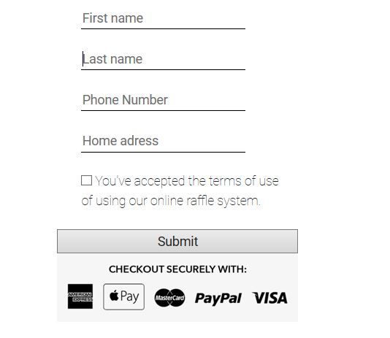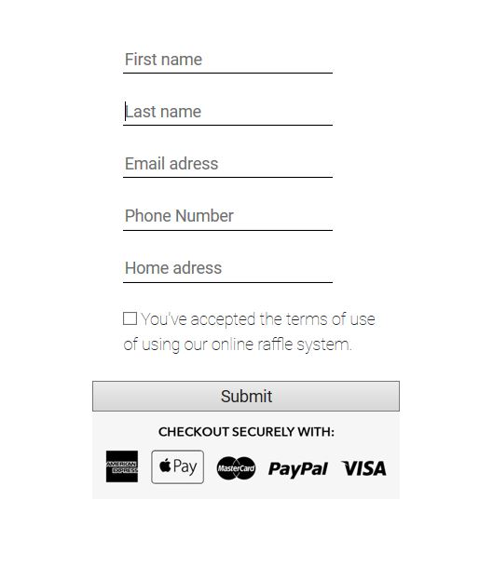

Although changes were made in the raffle checkout and menu bars to change how users navigate around and feel better in the site, meaning it surpassed the usability and functionality and user journey. Before the changes the original idea was to contact the customer who won the raffle via telephone but since most participants wanted an email marketing feature I’ve added an email option that allows the user to enter their email for further email marketing and to contact the customer who won the raffle via email and phone number.

When I created the website I've gotten inspired by the Chapelfield website which leads to the initial construction of the website, the quality and layout are almost close to each other.

One thing that I always carried consistently through my layouts where the Chapelfield menu bars on top which inspired the creation template for each page. My original design was more simplified as my target consumers would be older and providing a complex interface makes them less likely to use the website meaning it doesn't meet their requirements which I carried it on to my original website.

The banner was essential because I needed an image to show of the location as a Chapelfield did on theirs so I showed an image of the Norwich Kitchen not only but a timer promoting the raffle ticket and learn more button that redirects them to it. My original design was of a Cafe but I didn't end up liking it because too much was going on the image making it distracting feeling very off. Not long later I found my original image on the site banner. I've chosen it because it fits with the relaxed calm feeling of the website because the wallpaper doesn't have anyone there but just the shop interior view from a window that gives it a chilled out and more pleasing view of the Norwich kitchen.

Like the Chapelfield, I've always wanted to have a login but I didn't have enough time for that but this would have been a very good strategy for the business to gain recurring customers to hear the latest news about the Norwich Riverside Retail Park via phone or email marketing. I've decided to have a login terminal but it doesn't do much apart from giving the idea on how the experience of the website login would have looked like.

The three main options on the standout rectangle at the lower has also been consistent, I've simplified it making more readable and having an image of the right of someone young smiling with a simplistic white background to again appeal the younger youth without making it too obvious. This shows that having someone like that in the home page shows the riverside retail welcomes any young person but without making it obvious meaning that the older consumers won't see the site as just for teens only but people of all ages.

The website has three main Icons "shopping" "offers" "location". All of these three options appeal to the lower or lower-middle-class as it has the icon of the offer by showing them that they can get a good deal for the money just like how the Chapelfield website has a discount icon as well matching our target demographic. Shopping shows this site is dedicated to selling you something to do with the Riverside Retail Park showing to the consumers that are looking to buy locally that the riverside retail sells goods at a good price gaining more customers in the Norwich Riverside Retail park.

The only changes I've applied from the design to the original is that I've changed the image of the women because of the one on the concept design made the website attract more female young consumers by using a young girl shopping with an overly dramatic pink background making the unbalancing of the demographic hence why I've changed it to another image but something more neutral a young girl smiling in a clean and white background to represent the cleanness of the website.

Just like throughout my designs I carried 6 website cards I've gotten inspired by the Chapelfield in which they represent their store's rectangles and I liked that concept design because its a very genuine way of representing your local stores rather than having small text or logos with a link, this makes it easier to click on it and easy to read as they are massive meaning if a mobile user clicks on it their thumbs won't get in the way because it is too small already fixing a mobile users need and helps for people that struggle to read small text. And direction meets the main requirement as this informs the location of the place so customers located anywhere can go to the location to have a direction to get their meeting their needs.

[*Evidence of the review*](https://youtu.be/hbwS_Gd1Pgc)

Even though most of the stuff regarding the website is strength the site isn't perfect and lacks in some areas, firstly the mobile version is hard to navigate, and it isn't optimised for it as it was designed for computer browsers. This would lead to issues as most users use mobile phones every day to browse the internet meaning we are not focusing on a large portion. We can better optimise for this next time as when we are next building the site make sure it is optimised for mobile and next time better suited to meet the mobile user's expectations as revenue can be lost and the business isn't scaling at its potential.

Another thing would with large monitors the site sort of breaks up meaning that users with a small monitor has an advantage meaning users with a large screen will have trouble using the site and they'll have to resize the window to fit it on the screen manually displeasing them and making their experience in the site a hassle meaning they won't return again which can be the loss of a potential customer, the improvement we can implement is fixed the code so it goes by the size of the proportion of the screen.

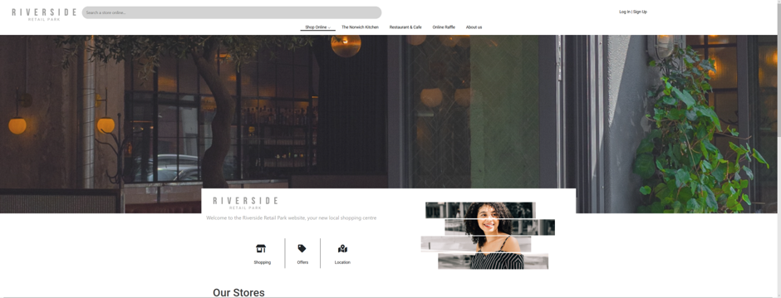

In this screenshot example it doesn’t look bad but its still displeasing seeing the menu search bar unaligned making the whole thing unbalanced.

Optimisation (M3,D2)

One rule that I've always follow is to keep all the files conscientiously organised and don't make it messy as it can slow down on workflow and be confusing meaning that developing the site will be more complicated than expected, so I've named everything relevant and kept the important images in the main file and the irrelevant ones in other folders.

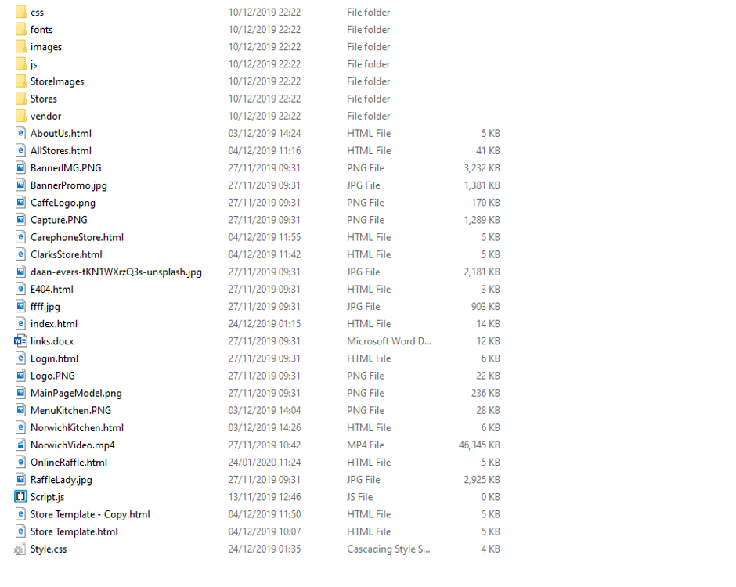

I've kept the performance good by compressing the images by Photoshop and sometimes I don't save images I access them by their image URL making it more simple to fetch them than making the file size of the website bigger storing images and in return, it begins to fetch files at a slower rate. It is important that your website is fast because of the lack of performance can make or break your business page. In the modern online world, people expect websites to load instantly and if it takes more than one second to load up a webpage or its very buggy and has issues people are not going to want to visit your site anymore or might just instantly leave as they don't want to wait for your website to keep up.

When I built the Riverside Retail I had this in mind about the performance and you'll see my website either has embedded code in it or it URL based image search rather than saving the images, even the font is imported by Google and the icons too drastically speeding up the websites speed meeting the demand speed for every modern website by the average consumer.

There are CSS scripts sometimes are in the HTML file but it doesn't get to the point that it slows down, although there are separate CSS files outside the HTML and also the JavaScript files this means that whenever it comes to code it is on a separate file and they are accessed separately speeding the loading time of the website is optimised. So in a nutshell all the JavaScript and CSS can be found outside the HTML files to increase the speed of the website it also makes it accessible to other devices. By not using WYSIWYG it means I don’t have any unnecessary code implemented. 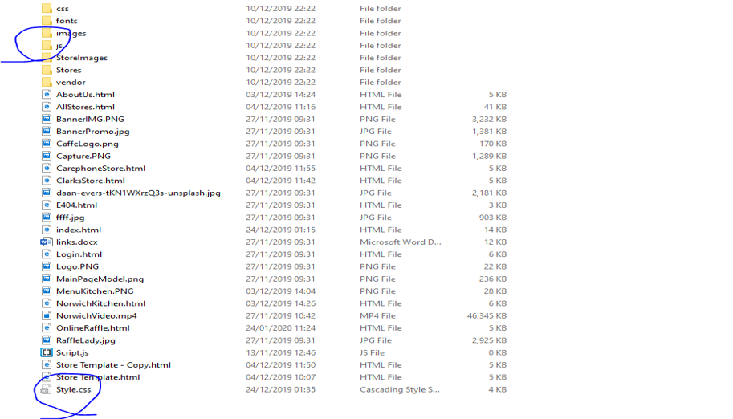

(Files/folders are circled in blue)

Evidence D2 & D3

**Statement**

I'm glad about the overall initial look of the website and glad it looks pleasing and met the requirement of the target audience. It wasn't easy and every concern I had I always could fund a workaround by searching on Google or doing home practice and it paid off well. I found my way diagnosing the issue and understood most of HTML and CSS and a little bit of JavaScript, so I never ran into proper significant issues. It was just time-consuming.

My creativity helped me a lot as I went by my instincts and planning to build a website and make it look not only powerful but suits its function and reliability. I didn't lack in the places that required me to think so I can safely state that I've very good in terms of creativity and an authentic clean design that fits the user requirements.

I took my time and thought carefully where each piece goes and manipulating it until I was happy. There would be moments where I felt like I wanted to speed up but I follow a strong regulation when building things. Quality is more representable than quantity. There were moments I asked Zoe, my teacher, for help but most of the time I tried to get along with my work and see if I can learn website creation independently. Although I did apply some plans on when I had to do certain actions or events always such as when I had to force myself to begin the website after training HTML and CSS. despite the poor time management, I'm personally happy with the result and it was worth the high-grade quality site.

